1 run......

training 1 epoch...

10.73496150970459 seconds used......

1 training finished! average train loss: 0.9655870145985058

evaluating...

Confusion matrix, without normalization

[[ 68 11 17]

[ 89 142 124]

[ 67 46 606]]

Normalized confusion matrix

[[0.70833333 0.11458333 0.17708333]

[0.25070423 0.4 0.34929577]

[0.09318498 0.06397775 0.84283727]]

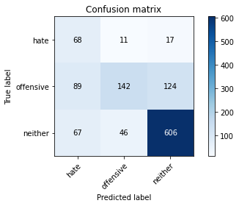

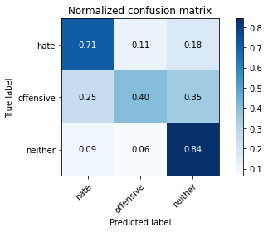

precision recall f1-score support

hate 0.30 0.71 0.42 96

offensive 0.71 0.40 0.51 355

neither 0.81 0.84 0.83 719

accuracy 0.70 1170

macro avg 0.61 0.65 0.59 1170

weighted avg 0.74 0.70 0.70 1170

average eval_loss: 0.6808109106653828, accuracy: 0.6974358974358974

training 2 epoch...

10.658955335617065 seconds used......

2 training finished! average train loss: 0.5718323327600956

evaluating...

Confusion matrix, without normalization

[[ 61 26 9]

[ 49 236 70]

[ 54 128 537]]

Normalized confusion matrix

[[0.63541667 0.27083333 0.09375 ]

[0.13802817 0.66478873 0.1971831 ]

[0.07510431 0.17802503 0.74687065]]

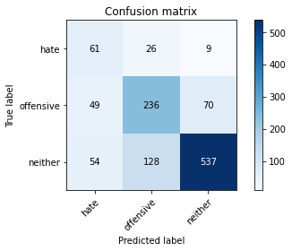

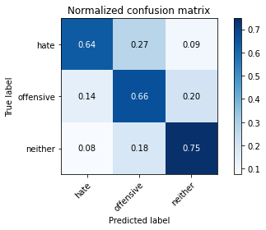

precision recall f1-score support

hate 0.37 0.64 0.47 96

offensive 0.61 0.66 0.63 355

neither 0.87 0.75 0.80 719

accuracy 0.71 1170

macro avg 0.62 0.68 0.64 1170

weighted avg 0.75 0.71 0.73 1170

average eval_loss: 0.6502086540399972, accuracy: 0.7128205128205128

training 3 epoch...

10.743569612503052 seconds used......

3 training finished! average train loss: 0.2613760663994721

evaluating...

Confusion matrix, without normalization

[[ 58 27 11]

[ 50 236 69]

[ 33 116 570]]

Normalized confusion matrix

[[0.60416667 0.28125 0.11458333]

[0.14084507 0.66478873 0.1943662 ]

[0.04589708 0.16133519 0.79276773]]

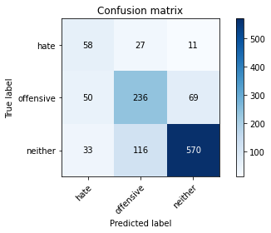

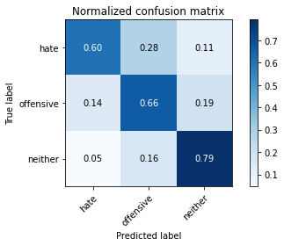

precision recall f1-score support

hate 0.41 0.60 0.49 96

offensive 0.62 0.66 0.64 355

neither 0.88 0.79 0.83 719

accuracy 0.74 1170

macro avg 0.64 0.69 0.66 1170

weighted avg 0.76 0.74 0.75 1170

average eval_loss: 0.6521964636394533, accuracy: 0.7384615384615385

training 4 epoch...

10.628208637237549 seconds used......

4 training finished! average train loss: 0.08106097502500884

evaluating...

Confusion matrix, without normalization

[[ 84 7 5]

[ 98 195 62]

[ 82 107 530]]

Normalized confusion matrix

[[0.875 0.07291667 0.05208333]

[0.27605634 0.54929577 0.17464789]

[0.11404729 0.1488178 0.73713491]]

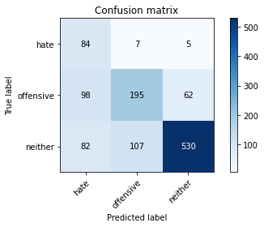

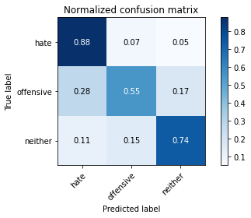

precision recall f1-score support

hate 0.32 0.88 0.47 96

offensive 0.63 0.55 0.59 355

neither 0.89 0.74 0.81 719

accuracy 0.69 1170

macro avg 0.61 0.72 0.62 1170

weighted avg 0.76 0.69 0.71 1170

average eval_loss: 1.033313647670261, accuracy: 0.6914529914529914

training 5 epoch...

10.73188066482544 seconds used......

5 training finished! average train loss: 0.04261211318329775

evaluating...

Confusion matrix, without normalization

[[ 70 25 1]

[ 76 245 34]

[ 73 183 463]]

Normalized confusion matrix

[[0.72916667 0.26041667 0.01041667]

[0.21408451 0.69014085 0.09577465]

[0.1015299 0.25452017 0.64394993]]

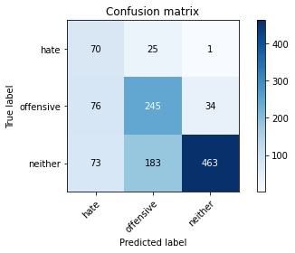

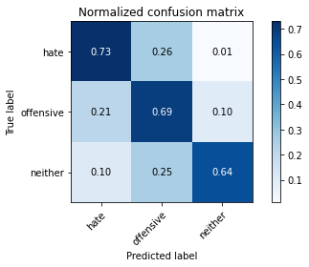

precision recall f1-score support

hate 0.32 0.73 0.44 96

offensive 0.54 0.69 0.61 355

neither 0.93 0.64 0.76 719

accuracy 0.66 1170

macro avg 0.60 0.69 0.60 1170

weighted avg 0.76 0.66 0.69 1170

average eval_loss: 1.2823083516904863, accuracy: 0.6649572649572649

training 6 epoch...

10.674702644348145 seconds used......

6 training finished! average train loss: 0.02594025529314032

evaluating...

Confusion matrix, without normalization

[[ 87 8 1]

[117 198 40]

[117 141 461]]

Normalized confusion matrix

[[0.90625 0.08333333 0.01041667]

[0.32957746 0.55774648 0.11267606]

[0.16272601 0.1961057 0.64116829]]

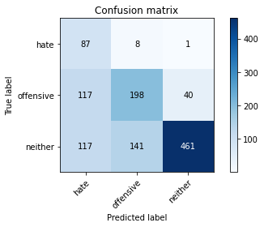

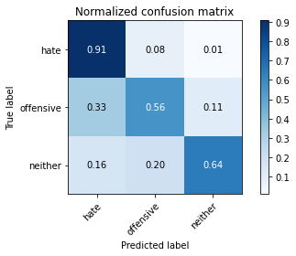

precision recall f1-score support

hate 0.27 0.91 0.42 96

offensive 0.57 0.56 0.56 355

neither 0.92 0.64 0.76 719

accuracy 0.64 1170

macro avg 0.59 0.70 0.58 1170

weighted avg 0.76 0.64 0.67 1170

average eval_loss: 1.5494078438160783, accuracy: 0.6376068376068376

training 7 epoch...

10.699550867080688 seconds used......

7 training finished! average train loss: 0.007883699677352394

evaluating...

Confusion matrix, without normalization

[[ 80 13 3]

[ 96 186 73]

[ 73 112 534]]

Normalized confusion matrix

[[0.83333333 0.13541667 0.03125 ]

[0.27042254 0.52394366 0.2056338 ]

[0.1015299 0.15577191 0.74269819]]

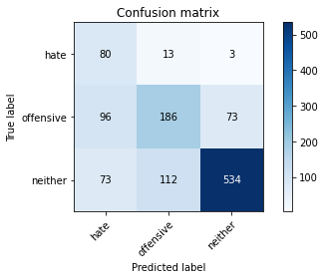

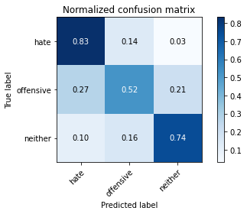

precision recall f1-score support

hate 0.32 0.83 0.46 96

offensive 0.60 0.52 0.56 355

neither 0.88 0.74 0.80 719

accuracy 0.68 1170

macro avg 0.60 0.70 0.61 1170

weighted avg 0.75 0.68 0.70 1170

average eval_loss: 1.3375007464724071, accuracy: 0.6837606837606838

training 8 epoch...

10.578554630279541 seconds used......

8 training finished! average train loss: 0.00953110458691039

evaluating...

Confusion matrix, without normalization

[[ 62 32 2]

[ 38 279 38]

[ 58 189 472]]

Normalized confusion matrix

[[0.64583333 0.33333333 0.02083333]

[0.10704225 0.78591549 0.10704225]

[0.08066759 0.26286509 0.65646732]]

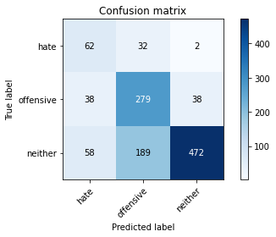

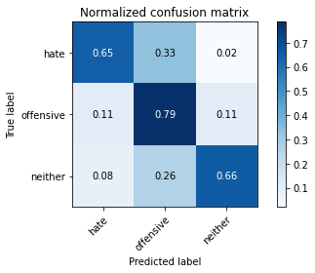

precision recall f1-score support

hate 0.39 0.65 0.49 96

offensive 0.56 0.79 0.65 355

neither 0.92 0.66 0.77 719

accuracy 0.69 1170

macro avg 0.62 0.70 0.64 1170

weighted avg 0.77 0.69 0.71 1170

average eval_loss: 1.4167547387591863, accuracy: 0.6948717948717948

training 9 epoch...

10.697219371795654 seconds used......

9 training finished! average train loss: 0.02039165191984336

evaluating...

Confusion matrix, without normalization

[[ 78 15 3]

[ 81 212 62]

[ 80 126 513]]

Normalized confusion matrix

[[0.8125 0.15625 0.03125 ]

[0.22816901 0.5971831 0.17464789]

[0.11126565 0.17524339 0.71349096]]

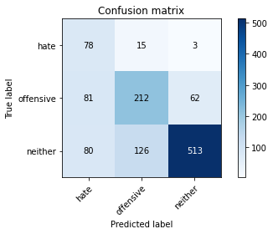

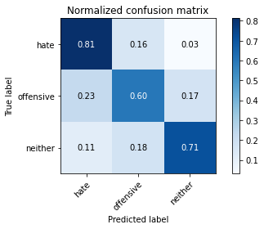

precision recall f1-score support

hate 0.33 0.81 0.47 96

offensive 0.60 0.60 0.60 355

neither 0.89 0.71 0.79 719

accuracy 0.69 1170

macro avg 0.60 0.71 0.62 1170

weighted avg 0.75 0.69 0.71 1170

average eval_loss: 1.217610861285258, accuracy: 0.6863247863247863

training 10 epoch...

10.584034442901611 seconds used......

10 training finished! average train loss: 0.009842299626533142

evaluating...

Confusion matrix, without normalization

[[ 77 17 2]

[ 74 230 51]

[ 78 145 496]]

Normalized confusion matrix

[[0.80208333 0.17708333 0.02083333]

[0.2084507 0.64788732 0.14366197]

[0.10848401 0.20166898 0.68984701]]

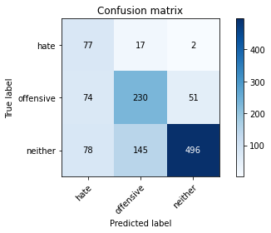

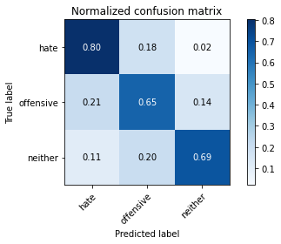

precision recall f1-score support

hate 0.34 0.80 0.47 96

offensive 0.59 0.65 0.62 355

neither 0.90 0.69 0.78 719

accuracy 0.69 1170

macro avg 0.61 0.71 0.62 1170

weighted avg 0.76 0.69 0.71 1170

average eval_loss: 1.369917029546479, accuracy: 0.6863247863247863

2 run......

training 1 epoch...

10.80285096168518 seconds used......

1 training finished! average train loss: 0.9430585067187037

evaluating...

Confusion matrix, without normalization

[[ 70 10 16]

[ 81 172 102]

[ 80 59 580]]

Normalized confusion matrix

[[0.72916667 0.10416667 0.16666667]

[0.22816901 0.48450704 0.28732394]

[0.11126565 0.08205841 0.80667594]]

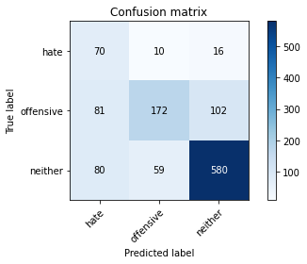

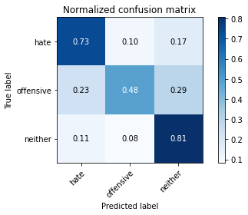

precision recall f1-score support

hate 0.30 0.73 0.43 96

offensive 0.71 0.48 0.58 355

neither 0.83 0.81 0.82 719

accuracy 0.70 1170

macro avg 0.62 0.67 0.61 1170

weighted avg 0.75 0.70 0.71 1170

average eval_loss: 0.6759559754597939, accuracy: 0.7025641025641025

training 2 epoch...

10.611410856246948 seconds used......

2 training finished! average train loss: 0.5404339406107154

evaluating...

Confusion matrix, without normalization

[[ 70 20 6]

[ 52 269 34]

[ 68 170 481]]

Normalized confusion matrix

[[0.72916667 0.20833333 0.0625 ]

[0.14647887 0.75774648 0.09577465]

[0.0945758 0.2364395 0.6689847 ]]

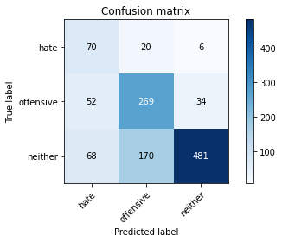

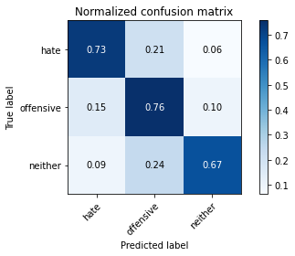

precision recall f1-score support

hate 0.37 0.73 0.49 96

offensive 0.59 0.76 0.66 355

neither 0.92 0.67 0.78 719

accuracy 0.70 1170

macro avg 0.63 0.72 0.64 1170

weighted avg 0.78 0.70 0.72 1170

average eval_loss: 0.7670305770332531, accuracy: 0.7008547008547008

training 3 epoch...

10.682856798171997 seconds used......

3 training finished! average train loss: 0.23062084505467542

evaluating...

Confusion matrix, without normalization

[[ 79 10 7]

[ 80 205 70]

[ 88 76 555]]

Normalized confusion matrix

[[0.82291667 0.10416667 0.07291667]

[0.22535211 0.57746479 0.1971831 ]

[0.12239221 0.10570236 0.77190542]]

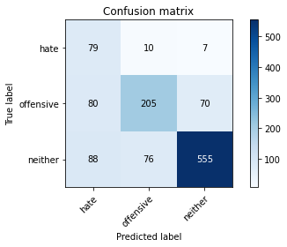

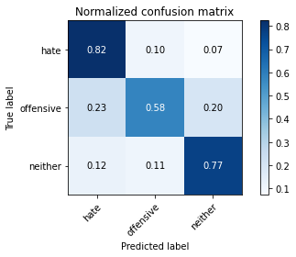

precision recall f1-score support

hate 0.32 0.82 0.46 96

offensive 0.70 0.58 0.63 355

neither 0.88 0.77 0.82 719

accuracy 0.72 1170

macro avg 0.63 0.72 0.64 1170

weighted avg 0.78 0.72 0.74 1170

average eval_loss: 0.8152530637838072, accuracy: 0.7170940170940171

training 4 epoch...

10.578392028808594 seconds used......

4 training finished! average train loss: 0.10002629344152021

evaluating...

Confusion matrix, without normalization

[[ 73 21 2]

[ 67 262 26]

[ 90 208 421]]

Normalized confusion matrix

[[0.76041667 0.21875 0.02083333]

[0.18873239 0.73802817 0.07323944]

[0.12517385 0.28929068 0.58553547]]

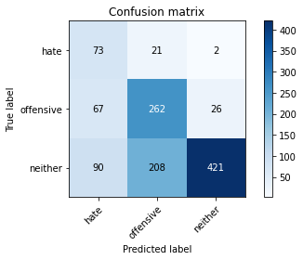

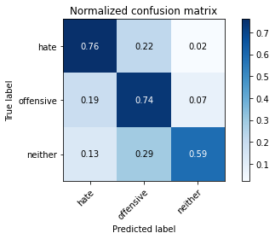

precision recall f1-score support

hate 0.32 0.76 0.45 96

offensive 0.53 0.74 0.62 355

neither 0.94 0.59 0.72 719

accuracy 0.65 1170

macro avg 0.60 0.69 0.60 1170

weighted avg 0.76 0.65 0.67 1170

average eval_loss: 1.3858484388408014, accuracy: 0.6461538461538462

training 5 epoch...

10.677561521530151 seconds used......

5 training finished! average train loss: 0.03261013734819634

evaluating...

Confusion matrix, without normalization

[[ 78 14 4]

[ 80 239 36]

[ 94 162 463]]

Normalized confusion matrix

[[0.8125 0.14583333 0.04166667]

[0.22535211 0.67323944 0.10140845]

[0.13073713 0.22531293 0.64394993]]

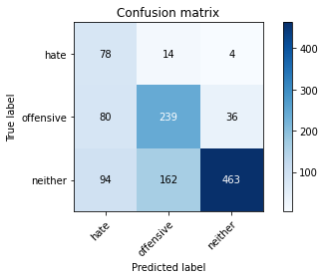

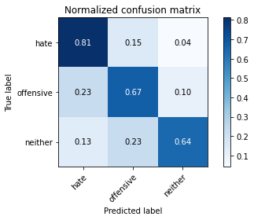

precision recall f1-score support

hate 0.31 0.81 0.45 96

offensive 0.58 0.67 0.62 355

neither 0.92 0.64 0.76 719

accuracy 0.67 1170

macro avg 0.60 0.71 0.61 1170

weighted avg 0.77 0.67 0.69 1170

average eval_loss: 1.4286591208587258, accuracy: 0.6666666666666666

training 6 epoch...

10.57973861694336 seconds used......

6 training finished! average train loss: 0.011136756505168575

evaluating...

Confusion matrix, without normalization

[[ 85 7 4]

[104 222 29]

[ 99 181 439]]

Normalized confusion matrix

[[0.88541667 0.07291667 0.04166667]

[0.29295775 0.62535211 0.08169014]

[0.13769124 0.25173853 0.61057024]]

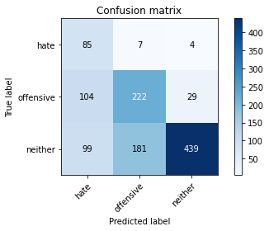

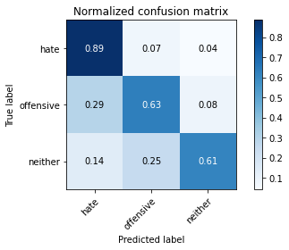

precision recall f1-score support

hate 0.30 0.89 0.44 96

offensive 0.54 0.63 0.58 355

neither 0.93 0.61 0.74 719

accuracy 0.64 1170

macro avg 0.59 0.71 0.59 1170

weighted avg 0.76 0.64 0.67 1170

average eval_loss: 1.782986758118969, accuracy: 0.6376068376068376

training 7 epoch...

10.721205472946167 seconds used......

7 training finished! average train loss: 0.004699928286364801

evaluating...

Confusion matrix, without normalization

[[ 78 14 4]

[ 76 219 60]

[ 60 106 553]]

Normalized confusion matrix

[[0.8125 0.14583333 0.04166667]

[0.21408451 0.61690141 0.16901408]

[0.08344924 0.14742698 0.76912378]]

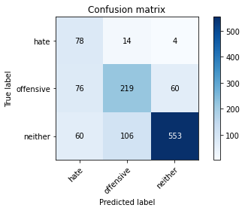

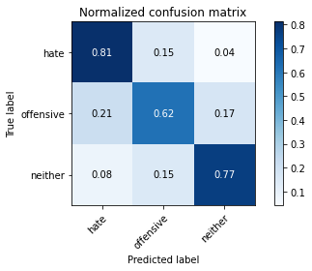

precision recall f1-score support

hate 0.36 0.81 0.50 96

offensive 0.65 0.62 0.63 355

neither 0.90 0.77 0.83 719

accuracy 0.73 1170

macro avg 0.64 0.73 0.65 1170

weighted avg 0.78 0.73 0.74 1170

average eval_loss: 1.3636461185701823, accuracy: 0.7264957264957265

training 8 epoch...

10.612865209579468 seconds used......

8 training finished! average train loss: 0.0034183531315647997

evaluating...

Confusion matrix, without normalization

[[ 79 15 2]

[ 78 248 29]

[ 84 197 438]]

Normalized confusion matrix

[[0.82291667 0.15625 0.02083333]

[0.21971831 0.69859155 0.08169014]

[0.11682893 0.27399166 0.60917942]]

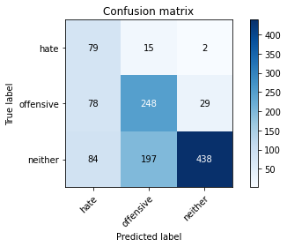

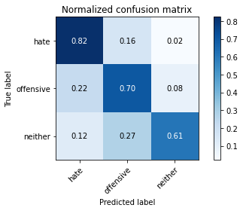

precision recall f1-score support

hate 0.33 0.82 0.47 96

offensive 0.54 0.70 0.61 355

neither 0.93 0.61 0.74 719

accuracy 0.65 1170

macro avg 0.60 0.71 0.60 1170

weighted avg 0.76 0.65 0.68 1170

average eval_loss: 1.9061250383571042, accuracy: 0.6538461538461539

training 9 epoch...

10.67862868309021 seconds used......

9 training finished! average train loss: 0.0036239015124530333

evaluating...

Confusion matrix, without normalization

[[ 78 15 3]

[ 74 234 47]

[ 74 151 494]]

Normalized confusion matrix

[[0.8125 0.15625 0.03125 ]

[0.2084507 0.65915493 0.13239437]

[0.10292072 0.21001391 0.68706537]]

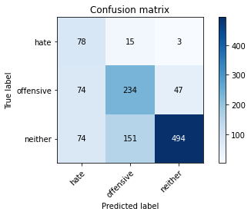

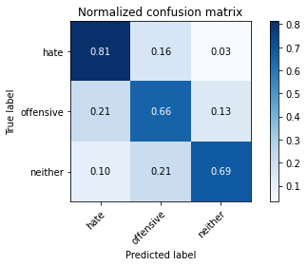

precision recall f1-score support

hate 0.35 0.81 0.48 96

offensive 0.58 0.66 0.62 355

neither 0.91 0.69 0.78 719

accuracy 0.69 1170

macro avg 0.61 0.72 0.63 1170

weighted avg 0.76 0.69 0.71 1170

average eval_loss: 1.7307598833310402, accuracy: 0.6888888888888889

training 10 epoch...

10.59778118133545 seconds used......

10 training finished! average train loss: 0.011872433740271455

evaluating...

Confusion matrix, without normalization

[[ 67 28 1]

[ 53 289 13]

[ 79 271 369]]

Normalized confusion matrix

[[0.69791667 0.29166667 0.01041667]

[0.14929577 0.81408451 0.03661972]

[0.10987483 0.37691238 0.5132128 ]]

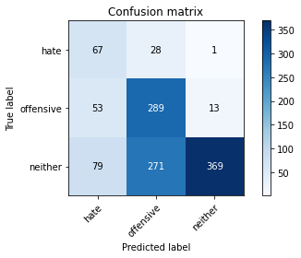

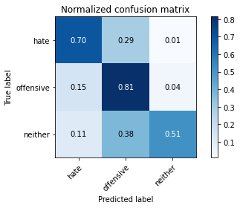

precision recall f1-score support

hate 0.34 0.70 0.45 96

offensive 0.49 0.81 0.61 355

neither 0.96 0.51 0.67 719

accuracy 0.62 1170

macro avg 0.60 0.68 0.58 1170

weighted avg 0.77 0.62 0.63 1170

average eval_loss: 2.3500046770451433, accuracy: 0.6196581196581197

3 run......

training 1 epoch...

10.589167594909668 seconds used......

1 training finished! average train loss: 0.9952214966927256

evaluating...

Confusion matrix, without normalization

[[ 84 6 6]

[184 100 71]

[157 51 511]]

Normalized confusion matrix

[[0.875 0.0625 0.0625 ]

[0.51830986 0.28169014 0.2 ]

[0.21835883 0.07093185 0.71070932]]

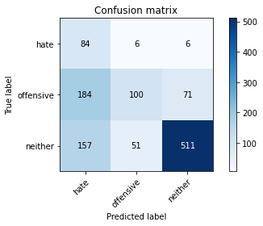

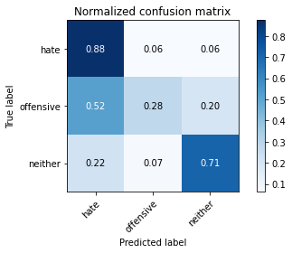

precision recall f1-score support

hate 0.20 0.88 0.32 96

offensive 0.64 0.28 0.39 355

neither 0.87 0.71 0.78 719

accuracy 0.59 1170

macro avg 0.57 0.62 0.50 1170

weighted avg 0.74 0.59 0.63 1170

average eval_loss: 0.872743910652096, accuracy: 0.594017094017094

training 2 epoch...

10.604266881942749 seconds used......

2 training finished! average train loss: 0.6553926010216985

evaluating...

Confusion matrix, without normalization

[[ 75 19 2]

[ 76 261 18]

[106 216 397]]

Normalized confusion matrix

[[0.78125 0.19791667 0.02083333]

[0.21408451 0.73521127 0.05070423]

[0.14742698 0.30041725 0.55215577]]

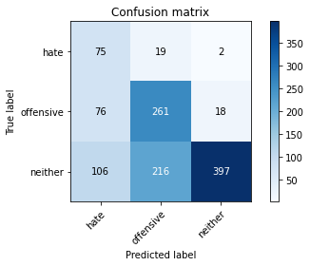

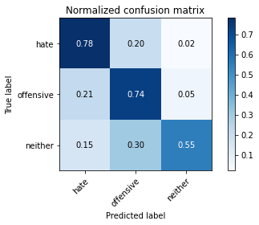

precision recall f1-score support

hate 0.29 0.78 0.42 96

offensive 0.53 0.74 0.61 355

neither 0.95 0.55 0.70 719

accuracy 0.63 1170

macro avg 0.59 0.69 0.58 1170

weighted avg 0.77 0.63 0.65 1170

average eval_loss: 0.947623867099568, accuracy: 0.6264957264957265

training 3 epoch...

10.612108945846558 seconds used......

3 training finished! average train loss: 0.31602504130985054

evaluating...

Confusion matrix, without normalization

[[ 88 7 1]

[158 168 29]

[185 124 410]]

Normalized confusion matrix

[[0.91666667 0.07291667 0.01041667]

[0.44507042 0.47323944 0.08169014]

[0.25730181 0.17246175 0.57023644]]

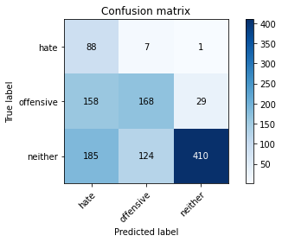

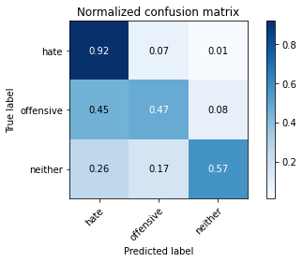

precision recall f1-score support

hate 0.20 0.92 0.33 96

offensive 0.56 0.47 0.51 355

neither 0.93 0.57 0.71 719

accuracy 0.57 1170

macro avg 0.57 0.65 0.52 1170

weighted avg 0.76 0.57 0.62 1170

average eval_loss: 1.3618806105549053, accuracy: 0.5692307692307692

training 4 epoch...

10.599689245223999 seconds used......

4 training finished! average train loss: 0.13181643447439587

evaluating...

Confusion matrix, without normalization

[[ 71 20 5]

[ 84 210 61]

[ 88 106 525]]

Normalized confusion matrix

[[0.73958333 0.20833333 0.05208333]

[0.23661972 0.5915493 0.17183099]

[0.12239221 0.14742698 0.73018081]]

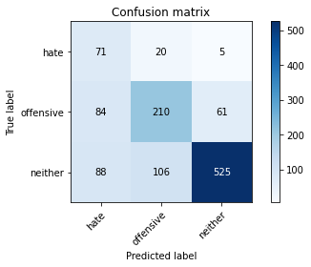

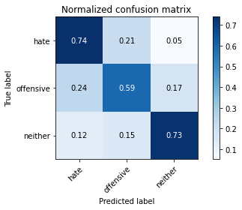

precision recall f1-score support

hate 0.29 0.74 0.42 96

offensive 0.62 0.59 0.61 355

neither 0.89 0.73 0.80 719

accuracy 0.69 1170

macro avg 0.60 0.69 0.61 1170

weighted avg 0.76 0.69 0.71 1170

average eval_loss: 1.0704129815606747, accuracy: 0.6888888888888889

training 5 epoch...

10.604923486709595 seconds used......

5 training finished! average train loss: 0.0562208621829216

evaluating...

Confusion matrix, without normalization

[[ 85 8 3]

[106 209 40]

[110 128 481]]

Normalized confusion matrix

[[0.88541667 0.08333333 0.03125 ]

[0.29859155 0.58873239 0.11267606]

[0.15299026 0.17802503 0.6689847 ]]

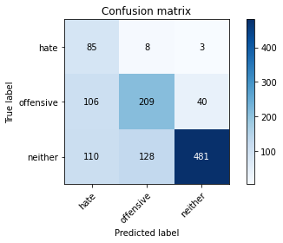

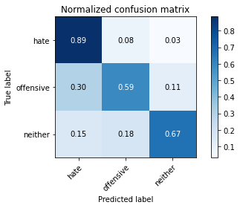

precision recall f1-score support

hate 0.28 0.89 0.43 96

offensive 0.61 0.59 0.60 355

neither 0.92 0.67 0.77 719

accuracy 0.66 1170

macro avg 0.60 0.71 0.60 1170

weighted avg 0.77 0.66 0.69 1170

average eval_loss: 1.4130533918485804, accuracy: 0.6623931623931624

training 6 epoch...

10.625694274902344 seconds used......

6 training finished! average train loss: 0.01602685301414957

evaluating...

Confusion matrix, without normalization

[[ 69 21 6]

[ 75 237 43]

[ 70 147 502]]

Normalized confusion matrix

[[0.71875 0.21875 0.0625 ]

[0.21126761 0.66760563 0.12112676]

[0.09735744 0.20445063 0.69819193]]

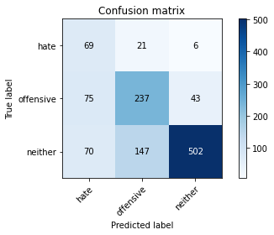

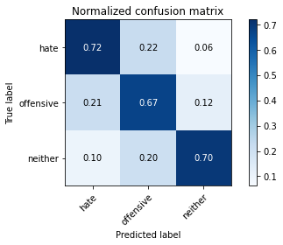

precision recall f1-score support

hate 0.32 0.72 0.45 96

offensive 0.59 0.67 0.62 355

neither 0.91 0.70 0.79 719

accuracy 0.69 1170

macro avg 0.61 0.69 0.62 1170

weighted avg 0.76 0.69 0.71 1170

average eval_loss: 1.3540177597837932, accuracy: 0.6905982905982906

training 7 epoch...

10.69724702835083 seconds used......

7 training finished! average train loss: 0.013174505939657268

evaluating...

Confusion matrix, without normalization

[[ 74 16 6]

[ 79 245 31]

[ 68 155 496]]

Normalized confusion matrix

[[0.77083333 0.16666667 0.0625 ]

[0.22253521 0.69014085 0.08732394]

[0.0945758 0.21557719 0.68984701]]

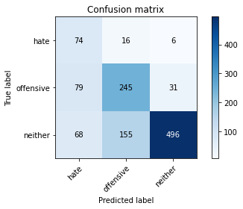

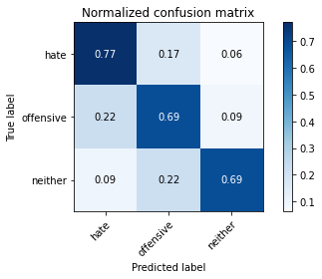

precision recall f1-score support

hate 0.33 0.77 0.47 96

offensive 0.59 0.69 0.64 355

neither 0.93 0.69 0.79 719

accuracy 0.70 1170

macro avg 0.62 0.72 0.63 1170

weighted avg 0.78 0.70 0.72 1170

average eval_loss: 1.428857992261143, accuracy: 0.6965811965811965

training 8 epoch...

10.617608070373535 seconds used......

8 training finished! average train loss: 0.04612351237821193

evaluating...

Confusion matrix, without normalization

[[ 65 27 4]

[ 50 286 19]

[ 63 237 419]]

Normalized confusion matrix

[[0.67708333 0.28125 0.04166667]

[0.14084507 0.8056338 0.05352113]

[0.0876217 0.32962448 0.58275382]]

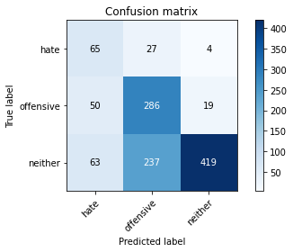

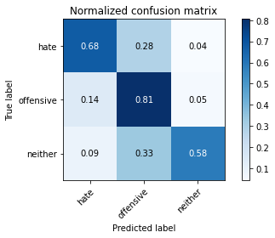

precision recall f1-score support

hate 0.37 0.68 0.47 96

offensive 0.52 0.81 0.63 355

neither 0.95 0.58 0.72 719

accuracy 0.66 1170

macro avg 0.61 0.69 0.61 1170

weighted avg 0.77 0.66 0.67 1170

average eval_loss: 1.5718434281268363, accuracy: 0.6581196581196581

training 9 epoch...

10.647730588912964 seconds used......

9 training finished! average train loss: 0.03379220442106349

evaluating...

Confusion matrix, without normalization

[[ 85 5 6]

[112 191 52]

[ 99 113 507]]

Normalized confusion matrix

[[0.88541667 0.05208333 0.0625 ]

[0.31549296 0.53802817 0.14647887]

[0.13769124 0.15716273 0.70514604]]

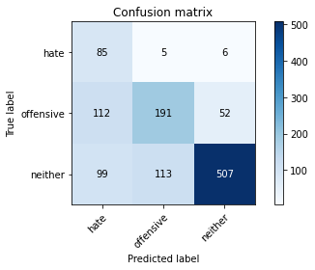

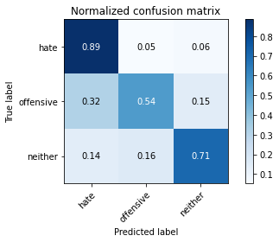

precision recall f1-score support

hate 0.29 0.89 0.43 96

offensive 0.62 0.54 0.58 355

neither 0.90 0.71 0.79 719

accuracy 0.67 1170

macro avg 0.60 0.71 0.60 1170

weighted avg 0.76 0.67 0.70 1170

average eval_loss: 1.4768407056897372, accuracy: 0.6692307692307692

training 10 epoch...

10.617035388946533 seconds used......

10 training finished! average train loss: 0.009189237043236582

evaluating...

Confusion matrix, without normalization

[[ 71 18 7]

[ 65 232 58]

[ 64 127 528]]

Normalized confusion matrix

[[0.73958333 0.1875 0.07291667]

[0.18309859 0.65352113 0.16338028]

[0.08901252 0.17663421 0.73435327]]

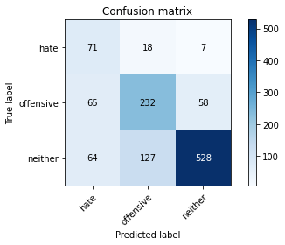

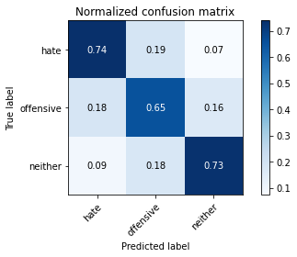

precision recall f1-score support

hate 0.35 0.74 0.48 96

offensive 0.62 0.65 0.63 355

neither 0.89 0.73 0.80 719

accuracy 0.71 1170

macro avg 0.62 0.71 0.64 1170

weighted avg 0.76 0.71 0.73 1170

average eval_loss: 1.3580397306862524, accuracy: 0.7102564102564103

4 run......

training 1 epoch...

10.598844051361084 seconds used......

1 training finished! average train loss: 1.0360315452728952

evaluating...

Confusion matrix, without normalization

[[ 68 13 15]

[ 91 192 72]

[ 81 110 528]]

Normalized confusion matrix

[[0.70833333 0.13541667 0.15625 ]

[0.25633803 0.54084507 0.2028169 ]

[0.11265647 0.15299026 0.73435327]]

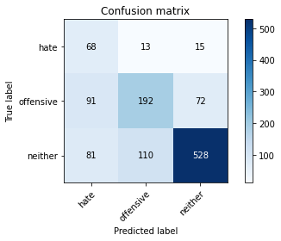

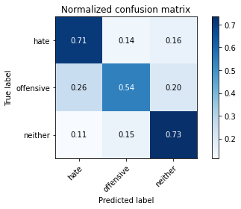

precision recall f1-score support

hate 0.28 0.71 0.40 96

offensive 0.61 0.54 0.57 355

neither 0.86 0.73 0.79 719

accuracy 0.67 1170

macro avg 0.58 0.66 0.59 1170

weighted avg 0.74 0.67 0.69 1170

average eval_loss: 0.7717398152513019, accuracy: 0.6735042735042736

training 2 epoch...

10.592192888259888 seconds used......

2 training finished! average train loss: 0.7083442163254533

evaluating...

Confusion matrix, without normalization

[[ 71 21 4]

[ 76 204 75]

[ 77 99 543]]

Normalized confusion matrix

[[0.73958333 0.21875 0.04166667]

[0.21408451 0.57464789 0.21126761]

[0.10709318 0.13769124 0.75521558]]

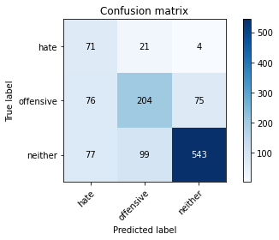

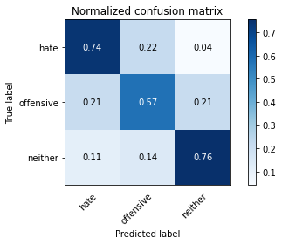

precision recall f1-score support

hate 0.32 0.74 0.44 96

offensive 0.63 0.57 0.60 355

neither 0.87 0.76 0.81 719

accuracy 0.70 1170

macro avg 0.61 0.69 0.62 1170

weighted avg 0.75 0.70 0.72 1170

average eval_loss: 0.6893142370854394, accuracy: 0.6991452991452991

training 3 epoch...

10.614897727966309 seconds used......

3 training finished! average train loss: 0.43096432302679333

evaluating...

Confusion matrix, without normalization

[[ 85 11 0]

[112 213 30]

[130 182 407]]

Normalized confusion matrix

[[0.88541667 0.11458333 0. ]

[0.31549296 0.6 0.08450704]

[0.18080668 0.25312935 0.56606398]]

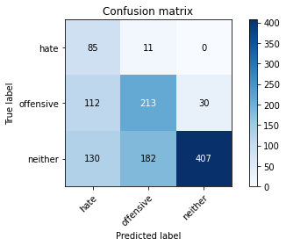

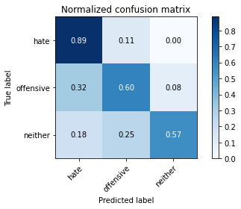

precision recall f1-score support

hate 0.26 0.89 0.40 96

offensive 0.52 0.60 0.56 355

neither 0.93 0.57 0.70 719

accuracy 0.60 1170

macro avg 0.57 0.68 0.56 1170

weighted avg 0.75 0.60 0.64 1170

average eval_loss: 1.0743462099867351, accuracy: 0.6025641025641025

training 4 epoch...

10.579574823379517 seconds used......

4 training finished! average train loss: 0.15759100126368658

evaluating...

Confusion matrix, without normalization

[[ 63 30 3]

[ 44 261 50]

[ 56 156 507]]

Normalized confusion matrix

[[0.65625 0.3125 0.03125 ]

[0.12394366 0.73521127 0.14084507]

[0.07788595 0.21696801 0.70514604]]

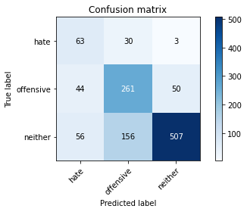

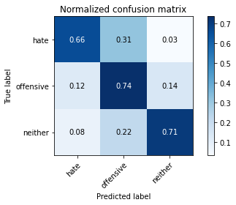

precision recall f1-score support

hate 0.39 0.66 0.49 96

offensive 0.58 0.74 0.65 355

neither 0.91 0.71 0.79 719

accuracy 0.71 1170

macro avg 0.63 0.70 0.64 1170

weighted avg 0.77 0.71 0.72 1170

average eval_loss: 0.9499040033857701, accuracy: 0.7102564102564103

training 5 epoch...

10.58569049835205 seconds used......

5 training finished! average train loss: 0.04780896779681955

evaluating...

Confusion matrix, without normalization

[[ 83 10 3]

[ 98 206 51]

[ 96 118 505]]

Normalized confusion matrix

[[0.86458333 0.10416667 0.03125 ]

[0.27605634 0.58028169 0.14366197]

[0.13351878 0.16411683 0.70236439]]

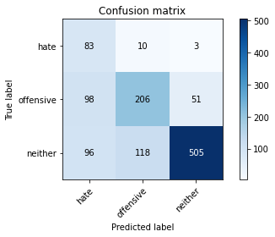

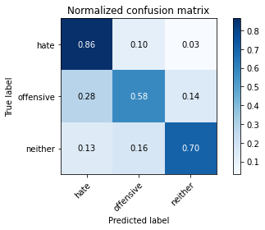

precision recall f1-score support

hate 0.30 0.86 0.45 96

offensive 0.62 0.58 0.60 355

neither 0.90 0.70 0.79 719

accuracy 0.68 1170

macro avg 0.61 0.72 0.61 1170

weighted avg 0.77 0.68 0.70 1170

average eval_loss: 1.3031642032881914, accuracy: 0.6786324786324787

training 6 epoch...

10.624001264572144 seconds used......

6 training finished! average train loss: 0.0658527240739204

evaluating...

Confusion matrix, without normalization

[[ 77 15 4]

[ 79 234 42]

[ 91 177 451]]

Normalized confusion matrix

[[0.80208333 0.15625 0.04166667]

[0.22253521 0.65915493 0.11830986]

[0.12656467 0.24617524 0.62726008]]

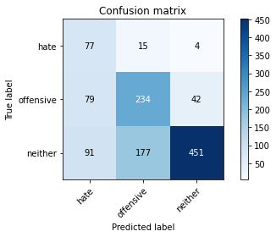

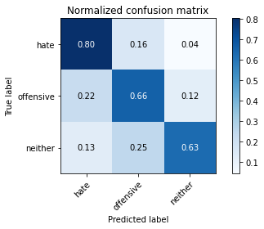

precision recall f1-score support

hate 0.31 0.80 0.45 96

offensive 0.55 0.66 0.60 355

neither 0.91 0.63 0.74 719

accuracy 0.65 1170

macro avg 0.59 0.70 0.60 1170

weighted avg 0.75 0.65 0.67 1170

average eval_loss: 1.3369842585870775, accuracy: 0.6512820512820513

training 7 epoch...

10.615986585617065 seconds used......

7 training finished! average train loss: 0.025416016443549388

evaluating...

Confusion matrix, without normalization

[[ 86 6 4]

[134 179 42]

[125 130 464]]

Normalized confusion matrix

[[0.89583333 0.0625 0.04166667]

[0.37746479 0.50422535 0.11830986]

[0.17385257 0.18080668 0.64534075]]

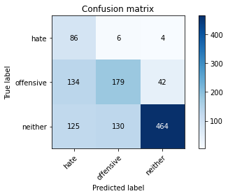

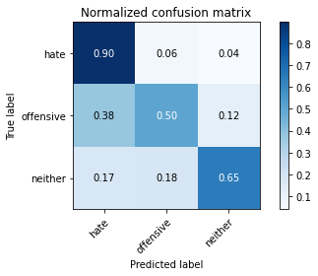

precision recall f1-score support

hate 0.25 0.90 0.39 96

offensive 0.57 0.50 0.53 355

neither 0.91 0.65 0.76 719

accuracy 0.62 1170

macro avg 0.58 0.68 0.56 1170

weighted avg 0.75 0.62 0.66 1170

average eval_loss: 1.9060777880377688, accuracy: 0.6230769230769231

training 8 epoch...

10.62837290763855 seconds used......

8 training finished! average train loss: 0.03549571421172004

evaluating...

Confusion matrix, without normalization

[[ 60 35 1]

[ 36 278 41]

[ 57 203 459]]

Normalized confusion matrix

[[0.625 0.36458333 0.01041667]

[0.10140845 0.78309859 0.11549296]

[0.07927677 0.28233658 0.63838665]]

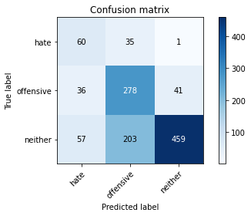

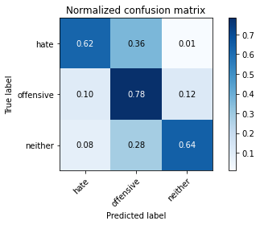

precision recall f1-score support

hate 0.39 0.62 0.48 96

offensive 0.54 0.78 0.64 355

neither 0.92 0.64 0.75 719

accuracy 0.68 1170

macro avg 0.62 0.68 0.62 1170

weighted avg 0.76 0.68 0.70 1170

average eval_loss: 1.4198613126399153, accuracy: 0.6811965811965812

training 9 epoch...

10.666750192642212 seconds used......

9 training finished! average train loss: 0.019179419439751655

evaluating...

Confusion matrix, without normalization

[[ 83 12 1]

[122 205 28]

[132 184 403]]

Normalized confusion matrix

[[0.86458333 0.125 0.01041667]

[0.34366197 0.57746479 0.07887324]

[0.18358832 0.25591099 0.5605007 ]]

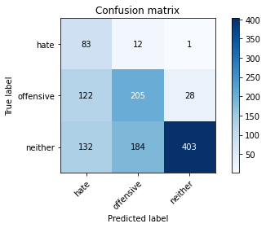

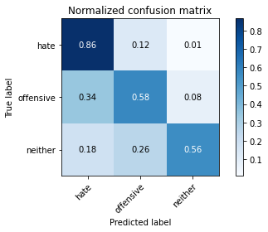

precision recall f1-score support

hate 0.25 0.86 0.38 96

offensive 0.51 0.58 0.54 355

neither 0.93 0.56 0.70 719

accuracy 0.59 1170

macro avg 0.56 0.67 0.54 1170

weighted avg 0.75 0.59 0.63 1170

average eval_loss: 2.1230771804259994, accuracy: 0.5905982905982906

training 10 epoch...

10.614903450012207 seconds used......

10 training finished! average train loss: 0.02452839102417264

evaluating...

Confusion matrix, without normalization

[[ 58 29 9]

[ 33 277 45]

[ 38 188 493]]

Normalized confusion matrix

[[0.60416667 0.30208333 0.09375 ]

[0.09295775 0.78028169 0.12676056]

[0.05285118 0.26147427 0.68567455]]

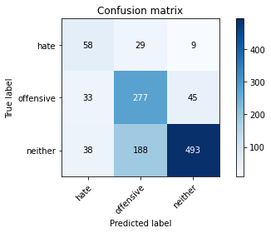

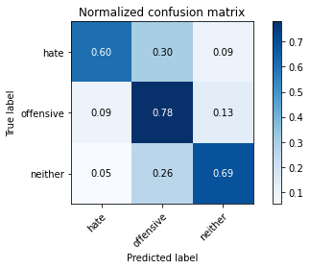

precision recall f1-score support

hate 0.45 0.60 0.52 96

offensive 0.56 0.78 0.65 355

neither 0.90 0.69 0.78 719

accuracy 0.71 1170

macro avg 0.64 0.69 0.65 1170

weighted avg 0.76 0.71 0.72 1170

average eval_loss: 1.295106674655009, accuracy: 0.7076923076923077

5 run......

training 1 epoch...

10.633623838424683 seconds used......

1 training finished! average train loss: 1.047434281025614

evaluating...

Confusion matrix, without normalization

[[ 55 34 7]

[ 66 242 47]

[103 189 427]]

Normalized confusion matrix

[[0.57291667 0.35416667 0.07291667]

[0.18591549 0.68169014 0.13239437]

[0.14325452 0.26286509 0.59388039]]

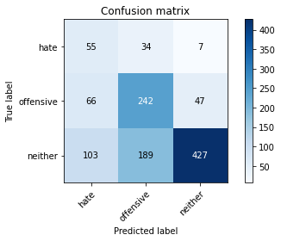

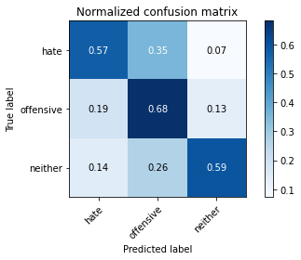

precision recall f1-score support

hate 0.25 0.57 0.34 96

offensive 0.52 0.68 0.59 355

neither 0.89 0.59 0.71 719

accuracy 0.62 1170

macro avg 0.55 0.62 0.55 1170

weighted avg 0.72 0.62 0.64 1170

average eval_loss: 0.8491064976837676, accuracy: 0.6188034188034188

training 2 epoch...

10.610566139221191 seconds used......

2 training finished! average train loss: 0.7129680226956095

evaluating...

Confusion matrix, without normalization

[[ 58 23 15]

[ 51 226 78]

[ 47 107 565]]

Normalized confusion matrix

[[0.60416667 0.23958333 0.15625 ]

[0.14366197 0.63661972 0.21971831]

[0.06536857 0.1488178 0.78581363]]

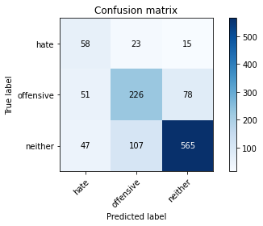

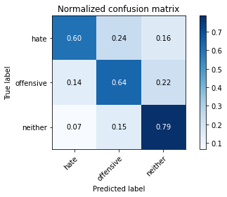

precision recall f1-score support

hate 0.37 0.60 0.46 96

offensive 0.63 0.64 0.64 355

neither 0.86 0.79 0.82 719

accuracy 0.73 1170

macro avg 0.62 0.68 0.64 1170

weighted avg 0.75 0.73 0.73 1170

average eval_loss: 0.6316624253483142, accuracy: 0.7256410256410256

training 3 epoch...

10.594766855239868 seconds used......

3 training finished! average train loss: 0.33858364900307997

evaluating...

Confusion matrix, without normalization

[[ 72 22 2]

[ 73 250 32]

[ 95 180 444]]

Normalized confusion matrix

[[0.75 0.22916667 0.02083333]

[0.2056338 0.70422535 0.09014085]

[0.13212796 0.25034771 0.61752434]]

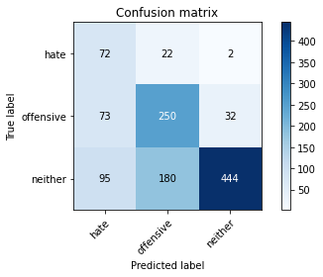

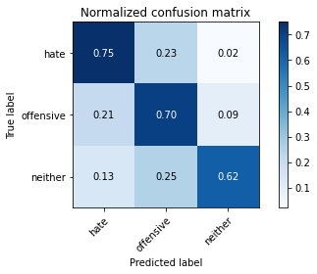

precision recall f1-score support

hate 0.30 0.75 0.43 96

offensive 0.55 0.70 0.62 355

neither 0.93 0.62 0.74 719

accuracy 0.65 1170

macro avg 0.59 0.69 0.60 1170

weighted avg 0.76 0.65 0.68 1170

average eval_loss: 0.9711270044415684, accuracy: 0.6547008547008547

training 4 epoch...

10.600275039672852 seconds used......

4 training finished! average train loss: 0.1025215348594689

evaluating...

Confusion matrix, without normalization

[[ 81 10 5]

[103 185 67]

[ 62 99 558]]

Normalized confusion matrix

[[0.84375 0.10416667 0.05208333]

[0.29014085 0.52112676 0.18873239]

[0.08623088 0.13769124 0.77607789]]

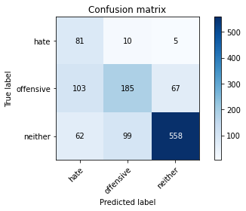

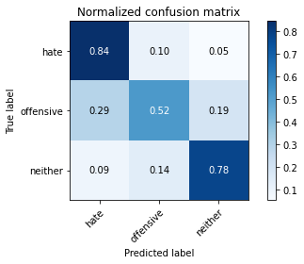

precision recall f1-score support

hate 0.33 0.84 0.47 96

offensive 0.63 0.52 0.57 355

neither 0.89 0.78 0.83 719

accuracy 0.70 1170

macro avg 0.61 0.71 0.62 1170

weighted avg 0.76 0.70 0.72 1170

average eval_loss: 0.9517706526538073, accuracy: 0.7042735042735043

training 5 epoch...

10.632839679718018 seconds used......

5 training finished! average train loss: 0.027403739056483443

evaluating...

Confusion matrix, without normalization

[[ 73 14 9]

[ 59 218 78]

[ 41 88 590]]

Normalized confusion matrix

[[0.76041667 0.14583333 0.09375 ]

[0.16619718 0.61408451 0.21971831]

[0.05702364 0.12239221 0.82058414]]

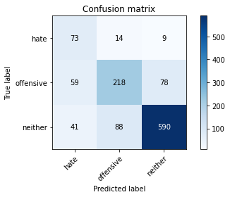

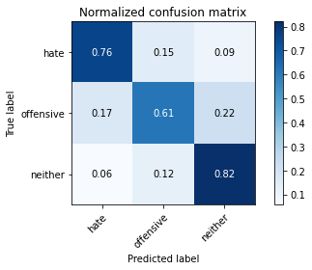

precision recall f1-score support

hate 0.42 0.76 0.54 96

offensive 0.68 0.61 0.65 355

neither 0.87 0.82 0.85 719

accuracy 0.75 1170

macro avg 0.66 0.73 0.68 1170

weighted avg 0.78 0.75 0.76 1170

average eval_loss: 0.9276260955859039, accuracy: 0.752991452991453

training 6 epoch...

10.614442586898804 seconds used......

6 training finished! average train loss: 0.017487577341463684

evaluating...

Confusion matrix, without normalization

[[ 57 36 3]

[ 36 284 35]

[ 41 224 454]]

Normalized confusion matrix

[[0.59375 0.375 0.03125 ]

[0.10140845 0.8 0.09859155]

[0.05702364 0.31154381 0.63143255]]

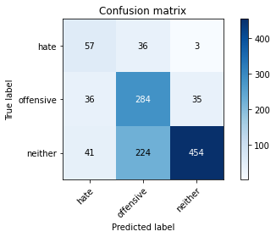

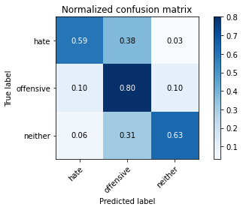

precision recall f1-score support

hate 0.43 0.59 0.50 96

offensive 0.52 0.80 0.63 355

neither 0.92 0.63 0.75 719

accuracy 0.68 1170

macro avg 0.62 0.68 0.63 1170

weighted avg 0.76 0.68 0.69 1170

average eval_loss: 1.4911437294745848, accuracy: 0.6794871794871795

training 7 epoch...

10.628800392150879 seconds used......

7 training finished! average train loss: 0.03038716044206272

evaluating...

Confusion matrix, without normalization

[[ 70 22 4]

[ 88 220 47]

[ 87 134 498]]

Normalized confusion matrix

[[0.72916667 0.22916667 0.04166667]

[0.24788732 0.61971831 0.13239437]

[0.12100139 0.18636996 0.69262865]]

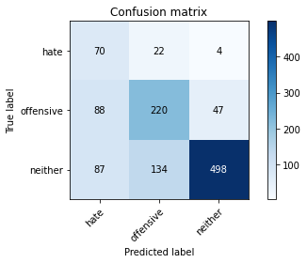

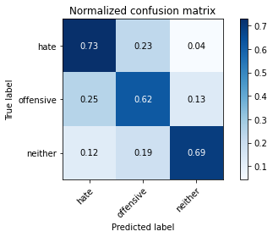

precision recall f1-score support

hate 0.29 0.73 0.41 96

offensive 0.59 0.62 0.60 355

neither 0.91 0.69 0.79 719

accuracy 0.67 1170

macro avg 0.59 0.68 0.60 1170

weighted avg 0.76 0.67 0.70 1170

average eval_loss: 1.4232665633751174, accuracy: 0.6735042735042736

training 8 epoch...

10.612186431884766 seconds used......

8 training finished! average train loss: 0.02621245957769653

evaluating...

Confusion matrix, without normalization

[[ 67 25 4]

[ 69 241 45]

[ 61 165 493]]

Normalized confusion matrix

[[0.69791667 0.26041667 0.04166667]

[0.1943662 0.67887324 0.12676056]

[0.08484006 0.2294854 0.68567455]]

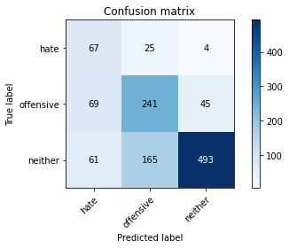

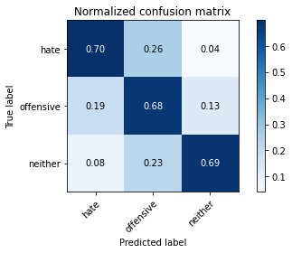

precision recall f1-score support

hate 0.34 0.70 0.46 96

offensive 0.56 0.68 0.61 355

neither 0.91 0.69 0.78 719

accuracy 0.68 1170

macro avg 0.60 0.69 0.62 1170

weighted avg 0.76 0.68 0.70 1170

average eval_loss: 1.4235499566894467, accuracy: 0.6846153846153846

training 9 epoch...

10.66557788848877 seconds used......

9 training finished! average train loss: 0.006271291130230695

evaluating...

Confusion matrix, without normalization

[[ 79 14 3]

[ 98 205 52]

[ 89 126 504]]

Normalized confusion matrix

[[0.82291667 0.14583333 0.03125 ]

[0.27605634 0.57746479 0.14647887]

[0.12378303 0.17524339 0.70097357]]

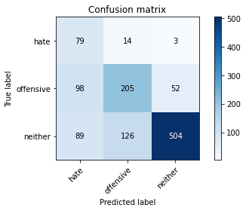

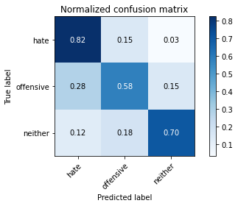

precision recall f1-score support

hate 0.30 0.82 0.44 96

offensive 0.59 0.58 0.59 355

neither 0.90 0.70 0.79 719

accuracy 0.67 1170

macro avg 0.60 0.70 0.60 1170

weighted avg 0.76 0.67 0.70 1170

average eval_loss: 1.4923737718392227, accuracy: 0.6735042735042736

training 10 epoch...

10.603309392929077 seconds used......

10 training finished! average train loss: 0.0021361023297816117

evaluating...

Confusion matrix, without normalization

[[ 78 15 3]

[ 96 202 57]

[ 84 123 512]]

Normalized confusion matrix

[[0.8125 0.15625 0.03125 ]

[0.27042254 0.56901408 0.16056338]

[0.11682893 0.17107093 0.71210014]]

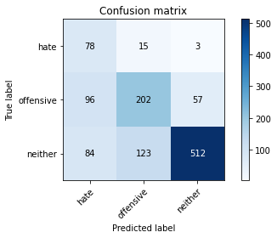

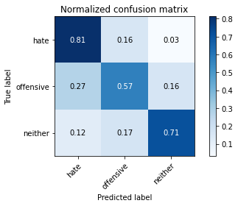

precision recall f1-score support

hate 0.30 0.81 0.44 96

offensive 0.59 0.57 0.58 355

neither 0.90 0.71 0.79 719

accuracy 0.68 1170

macro avg 0.60 0.70 0.61 1170

weighted avg 0.76 0.68 0.70 1170

average eval_loss: 1.551959924778696, accuracy: 0.676923076923077